In-Depth Research Report: Insecure Communication

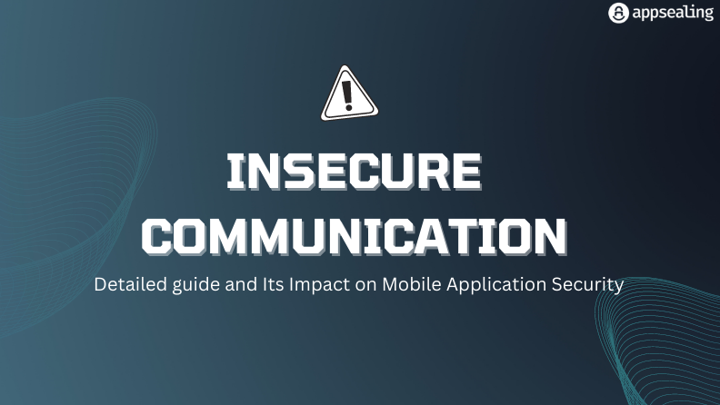

What is Insecure Communication?
Insecure communication refers to the transmission of sensitive information over unprotected or poorly protected communication channels, making it vulnerable to interception, manipulation, or theft by malicious actors. This flaw is commonly seen in software systems, mobile applications, and web services that fail to implement proper security measures during data exchange.
The sensitivity of data such as passwords, credit card details, personal information, and business-critical data necessitates secure communication channels to prevent unauthorized access or data breaches. Failing to secure communication channels exposes users and systems to a wide range of cyber threats, including man-in-the-middle (MITM) attacks, data leaks, and identity theft.

Methods of Insecure Communication
Plaintext Transmission of Sensitive Data
  - Description: Transmitting sensitive data, such as credentials or personal information, in plaintext over communication channels like HTTP.
  - Vulnerability: Data can be intercepted by attackers using tools like network sniffers (e.g., Wireshark).
  - Example: Sending login credentials over an unencrypted HTTP connection.
Lack of Encryption
  - Description: Failure to encrypt sensitive data at rest or in transit.
  - Vulnerability: Unencrypted data can be easily accessed if intercepted or stolen.
  - Example: Mobile applications that store user credentials in plaintext on the device.

Improper SSL/TLS Implementation
  - Description: Using outdated or weak versions of SSL/TLS protocols, such as SSL 3.0 or TLS 1.0, or misconfiguring certificates.
  - Vulnerability: Attackers can exploit weaknesses in outdated protocols to decrypt traffic.
  - Example: Websites with expired or self-signed certificates leading to MITM attacks.

Insecure Use of APIs
  - Description: Communication with APIs without proper authentication or encryption.
  - Vulnerability: Exposes API requests and responses to interception or tampering.
  - Example: Sending API keys or sensitive information over unsecured channels.
Hardcoded Credentials
  - Description: Embedding sensitive information, such as API keys or passwords, directly into the source code.
  - Vulnerability: Attackers who gain access to the code can exploit these credentials.
  - Example: Hardcoding a database password in a mobile app's source code.
Lack of Certificate Validation
  - Description: Failure to properly validate SSL/TLS certificates.
  - Vulnerability: Enables attackers to use fake certificates to intercept traffic.
  - Example: Accepting any certificate during an HTTPS handshake without verification.

Using Unsecured Communication Channels
  - Description: Reliance on insecure protocols like FTP, HTTP, or Telnet instead of secure alternatives like SFTP, HTTPS, or SSH.
  - Vulnerability: Such channels are prone to eavesdropping and MITM attacks.
  - Example: Transmitting financial data over HTTP.
No Authentication or Weak Authentication
  - Description: Lack of proper authentication mechanisms or use of weak credentials.
  - Vulnerability: Unauthorized users can access sensitive data.
  - Example: Allowing default or easily guessable passwords for communication endpoints.
Failure to Use Secure Key Exchange Mechanisms
  - Description: Using insecure methods to exchange cryptographic keys between parties.
  - Vulnerability: Enables attackers to intercept keys and decrypt communications.
  - Example: Exchanging keys over email without encryption.
Exposed Communication Logs
  - Description: Storing communication logs without encryption or access control.
  - Vulnerability: Logs may contain sensitive data that can be exploited.
  - Example: Plaintext logging of API responses containing user information.

Best Practices to Mitigate Insecure Communication
- Always use strong encryption protocols such as TLS 1.2 or higher.
- Implement proper SSL/TLS certificate validation.
- Use HTTPS for all web communications and secure alternatives like SFTP for file transfers.
- Avoid hardcoding credentials; use secure storage mechanisms instead.
- Employ robust authentication mechanisms, including multi-factor authentication.
- Regularly update and patch software to mitigate vulnerabilities in protocols.
- Secure communication logs by encrypting them and limiting access.

References
- OWASP Foundation. "OWASP Mobile Security Testing Guide." OWASP
- Stallings, W. (2016). Cryptography and Network Security: Principles and Practice. Pearson.
- SANS Institute. "Securing Web Communications." SANS
- MitM Attack Techniques and Prevention. "Kaspersky Lab." Kaspersky
- "SSL/TLS Best Practices." DigiCert. DigiCert

